International Hockey Goals

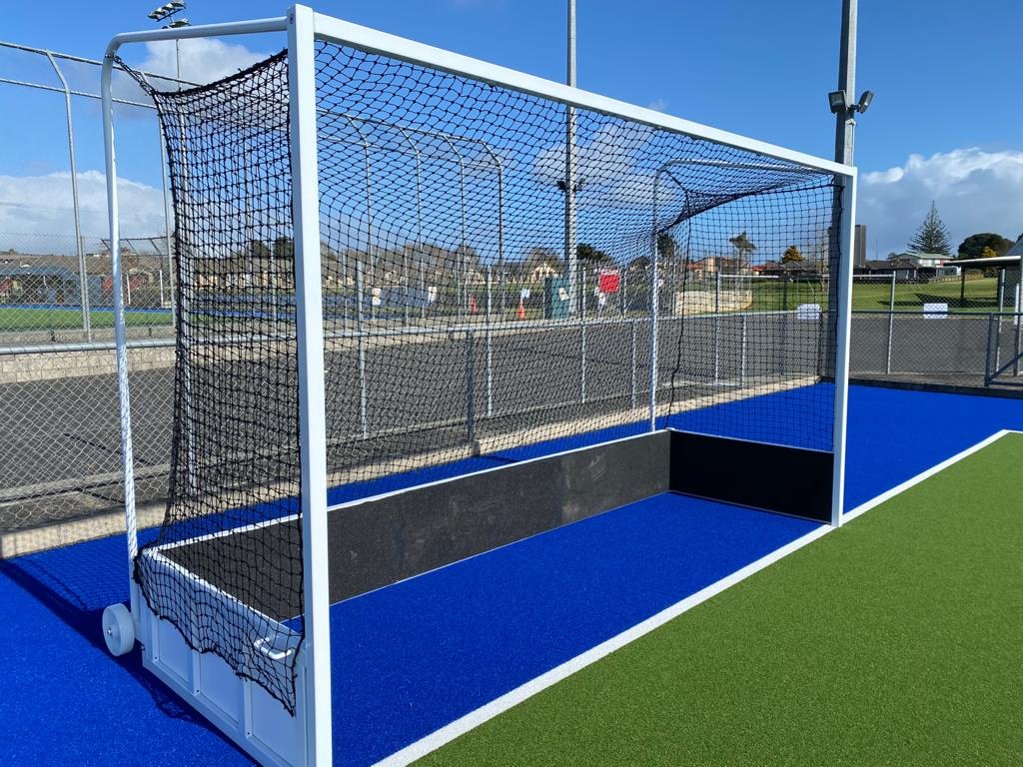

Each Hockey Goal consists of:

2 x Side frames

1x Base board

1 x Cross Bar

1 x Net - Standard Hockey Black

Box Contains:

2 x Turn Buckles

2 x Wheel Assemblies

1 x Cable Ties

Bolts & Fixings

Assembly Guide

- Assemble the goal as close as practical to where it is to be used.
- Identify all of the parts.
If you are assembling a pair of goals, then ensure that you are assembling 1 x left hand end frame and 1 x right hand end frame.
N.B. The timber base boards should be on the inside of the goal frame.
- With assistance from others, Put One Side Frame face down on the ground then bolt cross bars to the side frame making sure timber is on the inside of goal.
Once Cross bar is bolted on both right & left frames lift it up on a standing position,
- With assistance from others stand up one end frame and position the base board.
Sort out the wheel assemblies, one for each end of the goal. The wheels go to the back of the goal on the outside.
5 Now bolt the back base board to the sides. Repeat this for the other end frame.
- Open up the net and drape it over the goal frame. The net is held in place by stretching it over the net hooks on the frame.
  - Cable ties are also provided so that you can secure the net to the frame more permanently.
  - By using the handles on the outside of each end frame, the front of the goal can now be lifted by two people and the goal rolled on its wheels into position.

If in doubt please call 092949172

