Mobile Netball System Installation Instructions
The following instructions must be followed to ensure that this Mobile Netball System is not damaged during installation and that all parts are correctly installed. Mayfield Sports will not be held liable for any damage caused by incorrect or careless installation. If you have any questions regarding installation or if any of the instructions are not clear to you, please contact us on, phone 09 294 9172/ 021 764 202 or email: kevin@mayfieldsports.co.nz
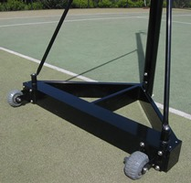
Equipment Checklist
- 1x Netball Post
- 1x Netball Base
- 2x Support Braces
- 2x Weights
- 1x Netball Hoop
- 1x Netball Net

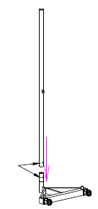
Step 1: Attach Netball Post to Base
- Insert Netball post into the base of the system
- Line up the hole in the base of the system with the hole in the Netball post
- Once both holes are lined up, insert bolt and tighten
- Check that the post is securely attached to base
Step 2: Attach Netball Hoop to Post
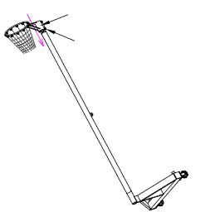
- Lean Netball System over
- Insert Netball hoop onto the top of post
- Set hoop to desired height and ensure hoop is straight
- Tighten hoop bolts
- Check that the hoop is securely attached to post
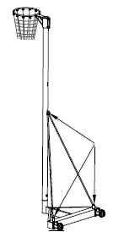
Step 3: Attach Support Braces
- Line up both support braces with the bolt holes on the base and post
- Once holes are lined up, insert bolts and tighten
- Check that support braces are securely attached

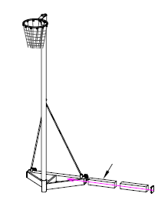
Step 4: Insert Weights into Base of System
- Unscrew screws on the side of system base
- Remove cover on the side of base
- Insert both weights into the base of the system
- Reattach cover to base
- Refasten cover screws
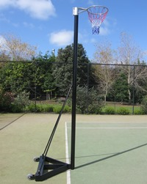

Your Mobile Netball System is Now Complete!

